Project Design Phase-II
Customer journey maps

Date | 19 September 2023
Team ID | NM2023TMID00044
Project Name | Quantitative Analysis of Candidates in 2019 Lok Sabha Elections
Maximum Marks | 4 Marks

1. Data Sources:
- Election Results Data: Obtain data on Lok Sabha election results in India for 2019. This should include information on constituencies, candidates, votes secured, and party affiliations.
- Voter Demographics Data: Gather data on voter demographics, such as age, gender, and socio-economic status.

2. Data Cleaning and Preparation:
- Clean, structure, and format the election results and voter demographics data for easy ingestion into statistical analysis tools. Handle missing values, remove duplicates, and aggregate data if necessary.

3. Statistical Analysis Tool:
- Choose a statistical analysis tool (like R, Python with Pandas, or any tool you prefer) for conducting quantitative analysis.

4. Data Connection:
- Connect the statistical analysis tool to your prepared data sources.

5. Data Modelling:
- Depending on the analysis requirements, create calculated fields or perform
statistical modelling.

6. Analysis Design:
- Plan the design of your quantitative analysis. Consider what statistical methods and tests will best represent the data.

7. Key Metrics and KPIs:
- Define key metrics and KPIs for the analysis, such as voter turnout, party-wise performance, demographic trends, etc.

8. Geographical Data (Optional):
- If you want to visualize regional impact, consider using geographic data, such as constituency boundaries.

9. User Testing:
- If applicable, test the analysis with stakeholders to ensure it provides meaningful insights.

10. Documentation:
- Document the data sources, cleaning steps, statistical methods used, and any assumptions made during the analysis. This documentation will aid in reproducing and understanding the analysis.

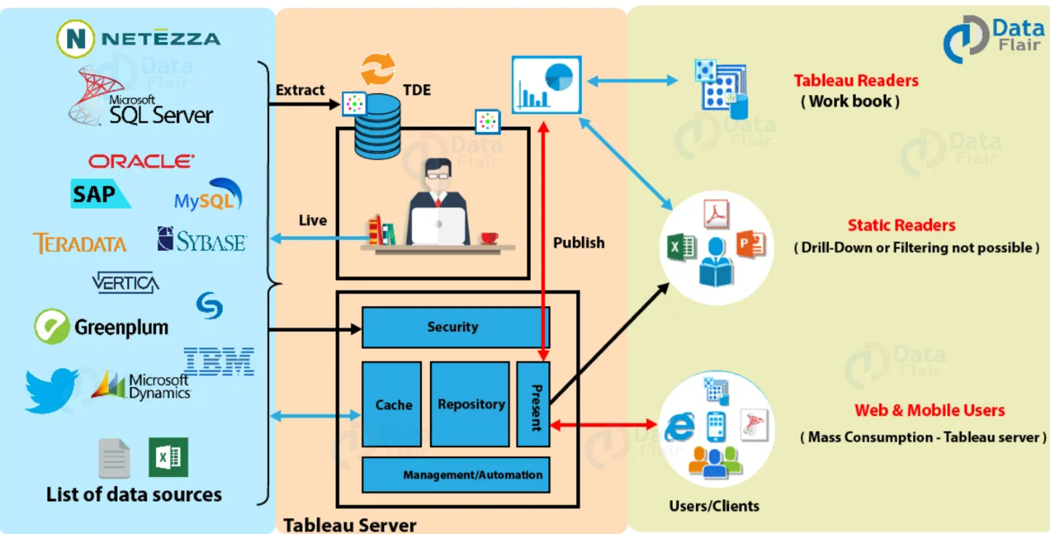

Reference:
https://data-flair.training/blogs/wp-content/uploads/sites/2/2019/03/Tableau-Architecture.jpg

